AERVION DRONETECH SOLUTIONS PVT. LTD.
"Innovating the Future Through
Drone Technology"
Drone Services | Inspection | Survey & Mapping | Monitoring | Aerial Solutions
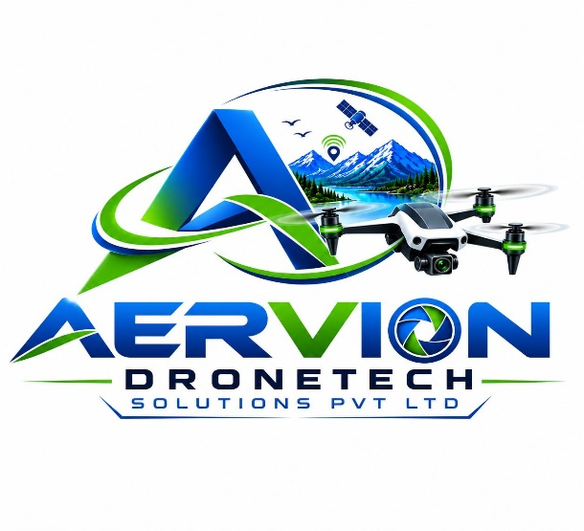

Contact Information
- 📞 +91 63824 14918
- 📞 +91 77088 86918
- 📧 Aerviondronetechsolutions@gmail.com
- 📍 Tamil Nadu, India

About Us
Company Overview
Aervion DroneTech Solutions Pvt. Ltd. is an emerging drone technology company focused on delivering innovative aerial solutions for industries across India. We specialize in drone-based inspection, surveying, mapping, monitoring, aerial photography, and customized UAV solutions.
Our mission is to help businesses improve efficiency, safety, and decision-making through advanced drone technology and data-driven insights.
Key Focus Areas
- Drone Inspection Services
- Survey & Mapping
- Solar Plant Inspection
- Wind Turbine Inspection
- Construction Monitoring
- Agricultural Drone Services
- Aerial Photography & Videography
- UAV Research & Development

Vision, Mission & Core Values
Vision
To become a leading drone technology company delivering innovative aerial solutions across infrastructure, energy, agriculture, construction, and industrial sectors.
Mission
To provide reliable, cost-effective, and technology-driven drone services that improve operational efficiency, safety, and productivity for our clients.

Core Values
- Innovation
- Safety First
- Professionalism
- Customer Satisfaction
- Integrity
- Continuous Improvement
Our Services
Drone Survey & Mapping
- Topographical Survey
- Land Survey
- GIS Mapping
- Orthomosaic Mapping
- Contour Mapping
Inspection Services
- Solar Plant Inspection
- Wind Turbine Inspection
- Power Line Inspection
- Industrial Asset Inspection
- Roof Inspection
Monitoring Services
- Construction Progress Monitoring
- Infrastructure Monitoring
- Site Documentation

Solar & Renewable Energy Solutions
Solar Plant Inspection
We provide drone-based solar inspection services to identify:
- Hotspots
- Damaged Modules
- Dirt Accumulation
- Performance Issues
- Thermal Defects
Benefits
- Faster Inspection
- Reduced Downtime
- Accurate Reports
- Cost Savings
- Improved Plant Efficiency
Industries Served
- Utility Scale Solar Farms
- Rooftop Solar Plants
- Industrial Solar Installations

Wind Turbine Inspection
Drone-Based Wind Turbine Inspection
Our
drone inspections help detect:
- Blade Cracks
- Surface Erosion
- Lightning Damage
- Structural Defects
- Maintenance Requirements
Advantages
- No Rope Access Required
- Reduced Risk
- Faster Inspection
- High-Resolution Imaging
- Cost Effective
- Transmission Lines

Construction & Infrastructure Solutions
Construction Monitoring
- Project Progress Tracking
- Site Documentation
- Volume Calculations
- Earthwork Analysis
- Stakeholder Reporting

Infrastructure Inspection
- Roads
- Bridges
- Railways
- Industrial Facilities
Agricultural Drone Solutions
Precision Agriculture
Services include:
- Crop Health Monitoring
- Field Mapping
- Crop Assessment
- Irrigation Analysis
- Agricultural Spraying Support
Benefits
- Improved Yield
- Reduced Costs
- Data-Driven Farming
- Better Resource Utilization
Technology & Capabilities
Our Capabilities
Drone Operations
- DGCA Compliant Operations
- Professional Flight Planning
- Data Collection
- Image Processing, Reporting & Analysis

Software & Data Processing
- GIS Mapping
- Photogrammetry
- Thermal Analysis
- 3D Modeling
- Digital Inspection Reports
Research & Development
Aervion DroneTech Solutions is committed to developing innovative UAV technologies and advanced aerial solutions through continuous research and development.
Why Choose Us
Why Aervion?
- Professional Team
- Advanced Drone Technology
- Industry-Focused Solutions
- Reliable Data Collection
- Safety Compliance
- Competitive Pricing
- Customized Service Packages
- Fast Project Delivery
Industries We Serve
Energy & Utilities
- Solar Power Plants
- Wind Farms
- Electrical Utilities

Construction
- Builders
- Infrastructure Developers
- EPC Contractors
Agriculture
- Farms
- Agri Businesses
- Agri Service Providers
Industrial
- Manufacturing Plants
- Warehouses
- Industrial Facilities
Government & Public Sector
- Smart City Projects
- Infrastructure Departments
- Survey Projects

Contact Us
Get In Touch
AERVION DRONETECH SOLUTIONS PVT. LTD.
📧 Aerviondronetechsolutions@gmail.com
📞 6382414918
📍 Tamil Nadu, India
Services
- Survey & Mapping
- Solar Inspection
- Wind Turbine Inspection
- Construction Monitoring
- Agricultural Drone Services
- Aerial Photography & Videography
"Transforming Industries Through Advanced Drone Technology."

